Result report

HW #5_A result

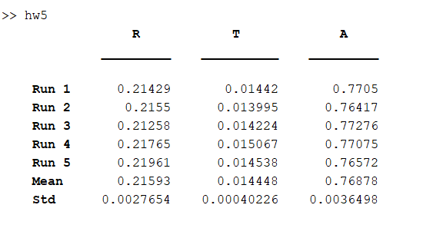

R Mean = 0.2159, Std = 0.0027 與理論值 0.22, 0.002 相近

T Mean = 0.0144, Std = 0.0004 與理論值 0.0145, 0.0004 相近

HW #5_B result